**Project Planning Phase**

**Project Planning Template (Product Backlog, Sprint Planning, Stories, Story points)**

|  |  |
| --- | --- |
| Date | 20 October 2022 |
| Team ID | PNT2022TMID30054 |
| Project Name | Project – Personal Expense Tracker Application |
| Maximum Marks | 8 Marks |

**Product Backlog, Sprint Schedule, and Estimation (4 Marks)**

Use the below template to create product backlog and sprint schedule

|  |  |  |  |  |  |  |
| --- | --- | --- | --- | --- | --- | --- |
| **Sprint** | **Functional**  **Requirement (Epic)** | **User Story Number** | **User Story / Task** | **Story Points** | **Priority** | **Team**  **Members** |
| Sprint-1 | Registration | USN-1 | As a user, I can register for the application by entering my email, password, and confirming my password. | 2 | High | Lavanya .s |
| Sprint-2 |  | USN-2 | As a user, I will receive confirmation email once I have registered for the application | 1 | High | Thoyadakshi .R |
| Sprint-3 |  | USN-3 | As a user, I can register for the application through Facebook | 2 | Low | Chaithanya.BS |
| Sprint-1  Sprint-1 | Login | USN-4  USN-5 | As a user, I can register for the application through Gmail  As a user, I can log into the application by entering email & password | 2  1 | Medium  High | C.Harithashree |
|  | Dashboard | USN-6 | As a user, I access my detail, manage my expense, add budget, expense report from the app etc.. | 2 | High | Lavanya.s |

**Project Tracker, Velocity & Burndown Chart: (4 Marks)**

|  |  |  |  |  |  |  |  |  |
| --- | --- | --- | --- | --- | --- | --- | --- | --- |
|  | **Sprint** | **Total Story Points** | **Duration** | **Sprint Start Date** | **Sprint End Date (Planned)** | **Story Points**  **Completed (as on**  **Planned End Date)** | **Sprint Release Date (Actual)** |  |
| Sprint-1 | 20 | 6 Days | 24 Oct 2022 | 29 Oct 2022 | 20 | 29 Oct 2022 |
| Sprint-2 | 20 | 6 Days | 31 Oct 2022 | 05 Nov 2022 | 18 | 06 Nov 2022 |
| Sprint-3 | 20 | 6 Days | 07 Nov 2022 | 12 Nov 2022 | 15 | 14 Nov 2022 |
| Sprint-4 | 20 | 6 Days | 14 Nov 2022 | 19 Nov 2022 | 19 | 21 Nov 2022 |
|  | |  |  |  |  |  |  | |

**Velocity:**

Imagine we have a 10-day sprint duration, and the velocity of the team is 20 (points per sprint). Let’s calculate the team’s average velocity (AV) per iteration unit (story points per day)

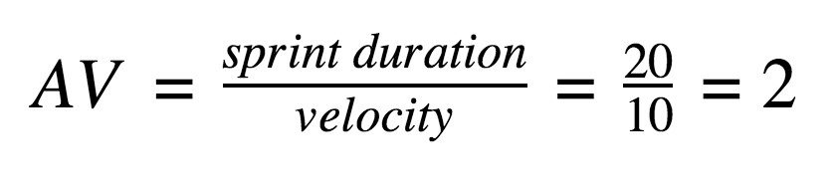

# Av = 1.8